PENETRATION TESTING REPORT
FOOTPRINTING & NETWORK SCANNING PHASES
W2-PM-FINAL | CYBERSECURITY | NETWORKWALKS
Pentester Name (Cybersecurity Professional) | Muhammad Yaqoob (MYMB)
Program/Batch | B084-Networkwalks
Date | 10-13 November 2026
Modules completed | W2-PM1 (Multiple Kali Tools)  W2-PM5 (Zenmap Scanning)
Client/Target | 1. Networkwalks (secured written permission already)  2. My own lab networks (Windows PC adapters and Kali VM network 10.0.0.0/24)
Permission secured from client? | Yes
Phases covered | Phase 1: Reconnaissance & Footprinting  Phase 2: Scanning & Network Discovery  Phase 3-5: In Progress

1. Liability Disclaimer
I have performed these activities only on the systems & devices where I had secured written permission or the devices/systems that I own myself. All these materials are for education and research purpose only. Do not use anything from here to break the law. The instructor, the authors and Networkwalks are not responsible for what you do with this knowledge. Every action you take is your own responsibility. Misuse can lead to criminal charges, heavy fines, loss of your job and a permanent record. In most countries unauthorised access is a crime even when nothing is damaged.

2. Introduction
This report covers footprinting the networkwalks.com domain using multiple Kali Linux tools (W2-PM1) and scanning my own local network with Zenmap (W2-PM5). One module covers the footprinting phase and the other covers the scanning phase, so together they show how an attacker moves from gathering public information to mapping live hosts on a network. It is the Week 2 part of my ongoing internship program at Networkwalks.
The footprinting commands were run in Kali Linux, which runs as a virtual machine in Oracle VirtualBox. The scanning was done with Zenmap on my Windows PC and on the same Kali virtual machine. Every step below includes the exact command used, the result I observed, a screenshot as evidence, and a short note on why the finding matters from an attacker's point of view.

3. Tools Used
The table below lists each tool used in this report and its purpose.
Tool | Purpose
Kali Linux (VirtualBox) | Operating system used for all reconnaissance and scanning activities.
WHOIS | Find domain registration details (registrar, dates, name servers).
whatweb | Fingerprint web technologies (server, CMS, plugins, IP).
nslookup | Resolve the domain name to its IP address using DNS.
curl -I | Read the HTTP response headers of the website.
wafw00f | Detect whether a Web Application Firewall protects the site.
Zenmap (Nmap GUI) | Run ping scans to find live hosts and view the network topology (Nmap 7.80 on Windows, Nmap 7.99 on Kali).
Windows PowerShell | Run ipconfig to identify the local IP address and subnet mask.

4. Activities Performed

4.1 Footprinting & Reconnaissance
I performed reconnaissance against the networkwalks.com domain using five Kali Linux tools: WHOIS, WhatWeb, Nslookup, Curl and Wafw00f. Each tool was used to collect a different type of information about the target.
Task 1 - WHOIS. I ran whois networkwalks.com to get the public registration record. The domain is registered with GoDaddy.com, LLC. It was created on 6 November 2019, last updated on 12 November 2025, and expires on 6 November 2027. The owner details are hidden by a privacy service (Domains By Proxy, LLC, Tempe, Arizona). The registry record lists two name servers, NS6135.HOSTGATOR.COM and NS6136.HOSTGATOR.COM. The registrar record also lists NS29.DOMAINCONTROL.COM and NS30.DOMAINCONTROL.COM. The domain has the four client lock statuses (delete, renew, transfer and update prohibited), which protect it from unwanted changes. DNSSEC is unsigned.
Task 2 - WhatWeb. I ran whatweb networkwalks.com to fingerprint the website. The HTTP address returned a 301 redirect to HTTPS, and the HTTPS site returned 200 OK. WhatWeb identified Apache as the web server, WordPress 7.1.4 with WordPress Download Manager 3.3.76, jQuery 3.7.1, Google Tag Manager and the page title "Networkwalks Academy". It also showed the IP address 192.232.216.135, the contact email info@networkwalks.com and the cookie __wpdm_client (marked HttpOnly).
Task 3 - Nslookup. I ran nslookup networkwalks.com to resolve the domain name. The non-authoritative answer was 192.232.216.135, which matches the IP address from WhatWeb. The query to the DNS server 10.0.0.1 timed out three times, and the answer then came from the DNS server 192.168.1.1. This is a note about my own lab DNS settings, not about the target.
Task 4 - Curl. I ran curl -I https://networkwalks.com to read the HTTP response headers. The server returned HTTP/2 200 with server: Apache. The link header exposed the WordPress REST API endpoint /wp-json/ and a page ID, and the cache headers x-endurance-cache-level and x-nginx-cache: WordPress showed the caching setup. The __wpdm_client cookie was set with the Secure and HttpOnly flags. I also ran curl -I networkwalks.com (plain HTTP). It returned 301 Moved Permanently with Location: https://networkwalks.com/ and X-Redirect-By: WordPress - Really Simple Security. The Apache version number was not shown, which is good. I did not see HSTS, X-Frame-Options, X-Content-Type-Options or Content-Security-Policy in these responses.
Task 5 - Wafw00f. I ran wafw00f networkwalks.com to check for a Web Application Firewall. After 2 requests, it reported that the site is behind ModSecurity (SpiderLabs).

4.2 Network Scanning with Zenmap
For the second activity, I used Zenmap (the graphical interface for Nmap) to find live hosts on my own lab networks. I used it in two places: on my Windows PC (Nmap 7.80) and on my Kali Linux virtual machine in Oracle VirtualBox (Nmap 7.99). All scans used the Ping scan profile, which runs nmap -sn and only checks which hosts are alive. It does not scan ports.
Step 1 - Identify my local IP address and subnet. On the Windows PC I ran ipconfig in PowerShell. It showed two relevant adapters. Ethernet 3 has the IPv4 address 192.168.56.1 with subnet mask 255.255.255.0, so its network is 192.168.56.0/24 (this looks like a VirtualBox host-only adapter). The Npcap Loopback Adapter has the auto-configured address 169.254.141.170 with subnet mask 255.255.0.0. Neither adapter has a default gateway, and the wireless adapter shown was disconnected.
Step 2 - Ping scan of my Windows addresses. On 12 November 2026 I ran nmap -sn 192.168.56.1 at 21:09 (Pakistan Standard Time). Nmap reported 1 IP address (1 host up) in 1.78 seconds. At 21:13 I ran nmap -sn 169.254.141.170, which also reported 1 host up in 1.71 seconds. After the second scan, both addresses were listed in the Zenmap Hosts panel. These two scans targeted single addresses, so they confirm my own adapters are up. A full scan of this network would use the range 192.168.56.0/24.
Step 3 - Ping scan of the Kali network 10.0.0.0/24. On the Kali virtual machine I entered 10.0.0.0/24 as the target, and Zenmap ran nmap -sn 10.0.0.0/24 (13 November 2026, 00:06 in the Kali time zone, UTC-5). Nmap finished with: 256 IP addresses (256 hosts up) scanned in 67.81 seconds. I saved the Nmap output to a file. It contains 256 "Host is up" entries from 10.0.0.0 to 10.0.0.255, with reported latencies from about 0.3 ms to 29 ms. No MAC addresses appear in this output.
Observation on the result. All 256 addresses were reported as up, including 10.0.0.0 (the network address) and 10.0.0.255 (the broadcast address), which normal devices do not use. A small lab network rarely has every address in use. Most likely something on the virtual network, such as the gateway or the virtualization layer, answers ping probes for every address. So this result does not prove that 256 real devices exist. It needs to be verified, for example by checking MAC addresses, using an ARP scan, or scanning from another machine.
Step 4 - Network topology. I opened the Topology tab in Zenmap. The Hosts panel lists the discovered addresses, and the view options for address and hostname labels were turned on. The topology shows the scanned hosts as green circles in rings around a central node, which is the scanning machine. Because there are 256 nodes, the labels overlap and the graph is crowded. The Legend and Save Graphic buttons are available at the top right of the Topology tab.
Step 5 - Mistake: wrong target. On 13 November 2026 at 10:04 I entered 255.255.255.0 (the subnet mask from ipconfig) as the target. Nmap treated it as an IP address, reported 0 hosts up, and showed the error get_srcaddr: can't connect socket: A socket operation was attempted to an unreachable network. The lesson is that the target must be an IP address or a network range such as 192.168.56.0/24, not the subnet mask.

5. Risk Analysis / Impact
Based on the information collected during the footprinting and network scanning activities, I identified the following potential risks.
# | Risk / Finding | Evidence / Observation | Potential Impact | Risk Level
1 | Web technology and version information exposed | WhatWeb identified WordPress 7.1.4 and WordPress Download Manager 3.3.76, plus jQuery 3.7.1 and Google Tag Manager. | Attackers may use exposed software and version information to look for known issues, so these components need regular review and patching. | ● Medium
2 | Missing security headers in captured responses | The curl -I responses did not show Strict-Transport-Security, X-Frame-Options, X-Content-Type-Options or Content-Security-Policy. | Without HSTS the first request can start over plain HTTP (the site redirects with a 301). Missing headers reduce browser-side protection. | ● Medium
3 | HTTP technical information exposed | Headers exposed the WordPress REST API (/wp-json/), a page ID, and cache headers (X-Endurance-Cache-Level, X-nginx-cache). | May help technology fingerprinting and further enumeration of the WordPress site. | ● Low
4 | Server IP address identifiable | Nslookup and WhatWeb both showed 192.232.216.135. | Provides information about the network location of the web service. | ● Low
5 | WAF technology identifiable | Wafw00f identified ModSecurity (SpiderLabs) after 2 requests. | Reveals information about the web application's security architecture. The WAF itself is a positive control. | ● Low
6 | Domain and DNS configuration information | WHOIS shows GoDaddy as registrar, HostGator and DomainControl name servers, and DNSSEC unsigned. Owner details are hidden by Domains By Proxy. | Name servers and dates are public. Unsigned DNSSEC gives no protection against forged DNS answers. | ● Low
7 | All addresses in the local subnet reported as up | Zenmap ping scan of 10.0.0.0/24 reported 256 of 256 hosts up, including 10.0.0.0 and 10.0.0.255. | Unknown devices may be present on a network. This result is probably caused by something answering for every address, so it is unreliable and needs verification. | ● Low
Risk level key: ● Critical ● Medium ● Low
The risks above are observations from the footprinting and scanning exercises, not confirmed vulnerabilities.
The practical exercises primarily involved information gathering and host discovery. No exploitation or vulnerability validation was performed as part of these two modules.
Therefore, the presence of information such as a software version, IP address or DNS record does not by itself mean that the system is vulnerable. Further authorized security testing would be required to confirm any actual vulnerability.

6. Recommendations
Based on the observations from these activities, I recommend the following security improvements:
- Review publicly exposed technology information
Organizations should regularly review what information about their web technologies, CMS and plugins is publicly visible.
- Keep software updated
WordPress, WordPress Download Manager and other plugins should be updated regularly and checked against current security advisories.
- Add security headers
Enable HSTS and consider X-Frame-Options, X-Content-Type-Options and a Content-Security-Policy, so browsers apply more protection.
- Review HTTP headers and the REST API
Check whether headers such as the REST API link and cache headers expose more than needed, and review which `/wp-json/` endpoints need to be public.
- Consider enabling DNSSEC
Signing the domain protects users from forged DNS answers. The name server lists in the registry and registrar records should also be checked for consistency.
- Properly configure and monitor the WAF
Keep the WAF (ModSecurity) enabled and tuned, since it already helps block common attacks.
- Perform regular internal network discovery
Organizations should periodically scan their own networks to identify active devices, and confirm the results with a second method (for example MAC addresses or an ARP scan).
- Investigate unknown devices
Any unexpected device found during network scanning should be investigated and verified.
- Maintain network documentation
Network topology and device information should be documented and updated regularly.
- Perform security testing with authorization
Reconnaissance and scanning should only be performed against systems and networks where appropriate authorization has been provided.

7. Conclusion
During Week 2 of my Cybersecurity & Ethical Hacking internship, I completed practical activities covering footprinting, reconnaissance and network scanning.
In the footprinting activity, I used five Kali Linux tools to collect information about the target domain. I learned how WHOIS shows domain registration details, WhatWeb identifies web technologies, Nslookup resolves domain names, Curl shows HTTP headers, and Wafw00f identifies a WAF.
In the network scanning activity, I used ipconfig to find my local IP addresses and subnet, and Zenmap to run ping scans on my Windows PC and on my Kali network. I also viewed the network topology. I learned that scan results must be checked carefully: the scan of 10.0.0.0/24 reported all 256 addresses as up, which is not realistic for a small lab. I also learned to enter a correct target, because my scan of the subnet mask 255.255.255.0 found nothing.
The exercises showed me that information gathering is an important part of cybersecurity. Even before attempting to exploit a system, a security professional can learn a significant amount about an environment by carefully analyzing publicly available information and network responses.
I also learned that technical findings should be documented clearly. A good cybersecurity report should explain what was performed, what was discovered, what the observation means, what risk it may create, and what can be done to reduce that risk.
Finally, I learned that reconnaissance and scanning must always be performed within an authorized scope. These activities were completed as part of the assigned educational cybersecurity lab.

8. Evidences Collected
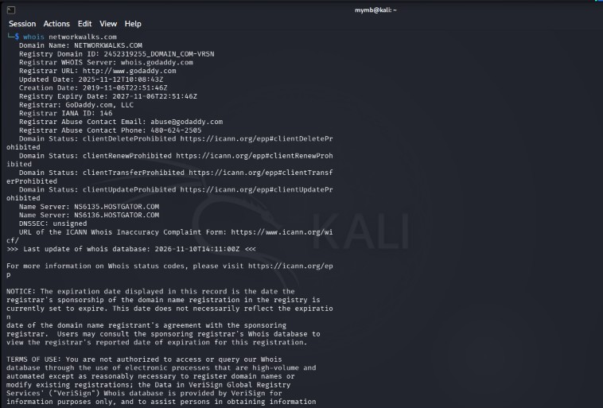
Figure 1a: Task 1 - WHOIS record for networkwalks.com (registry data).
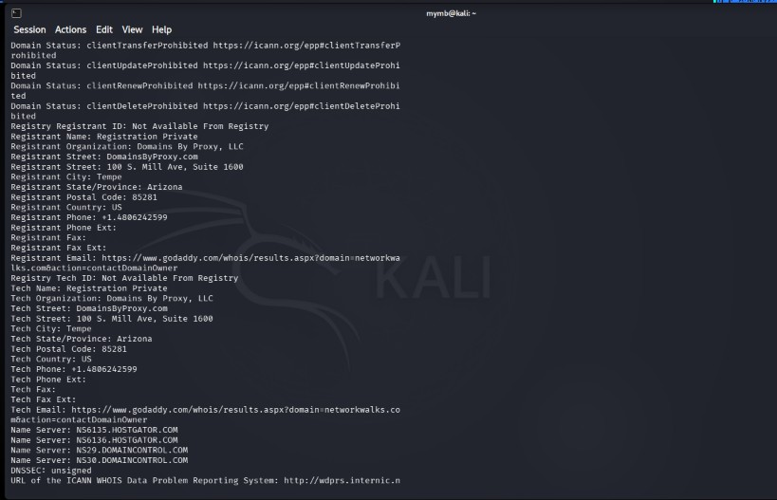
Figure 1b: Task 1 - WHOIS record (registrar data, privacy-protected registrant, name servers).
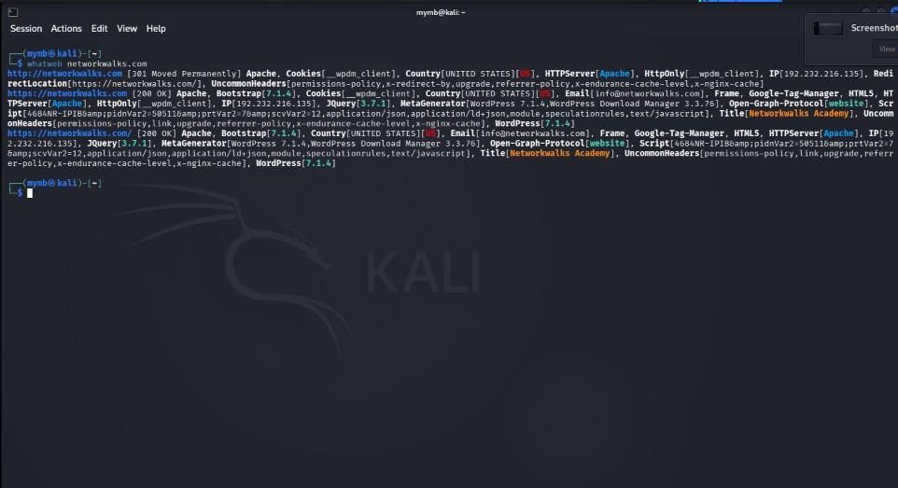
Figure 2: Task 2 - WhatWeb fingerprint of networkwalks.com.
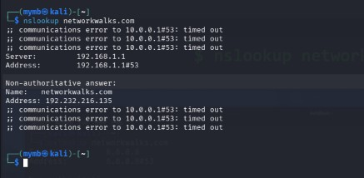
Figure 3: Task 3 - Nslookup resolving networkwalks.com to 192.232.216.135.
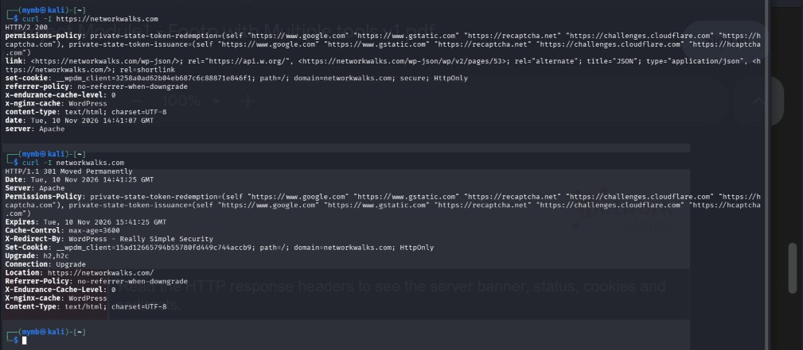
Figure 4: Task 4 - HTTP response headers using curl -I (HTTPS and HTTP).
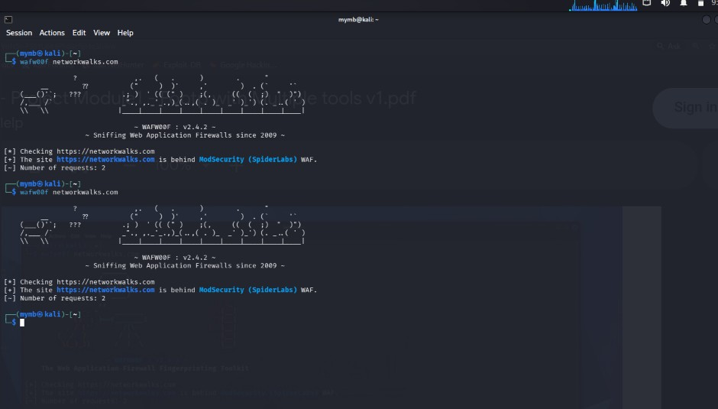
Figure 5: Task 5 - Wafw00f detecting ModSecurity (SpiderLabs).
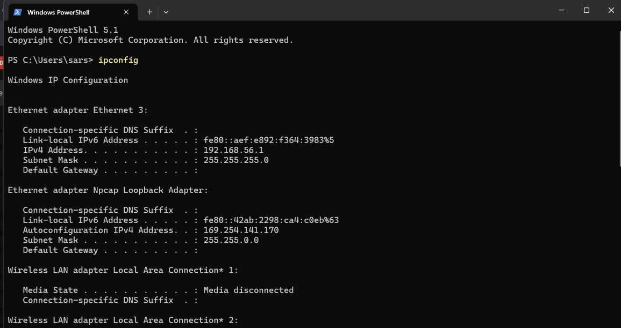
Figure 6: Windows PowerShell ipconfig showing 192.168.56.1 (255.255.255.0) and 169.254.141.170 (255.255.0.0).
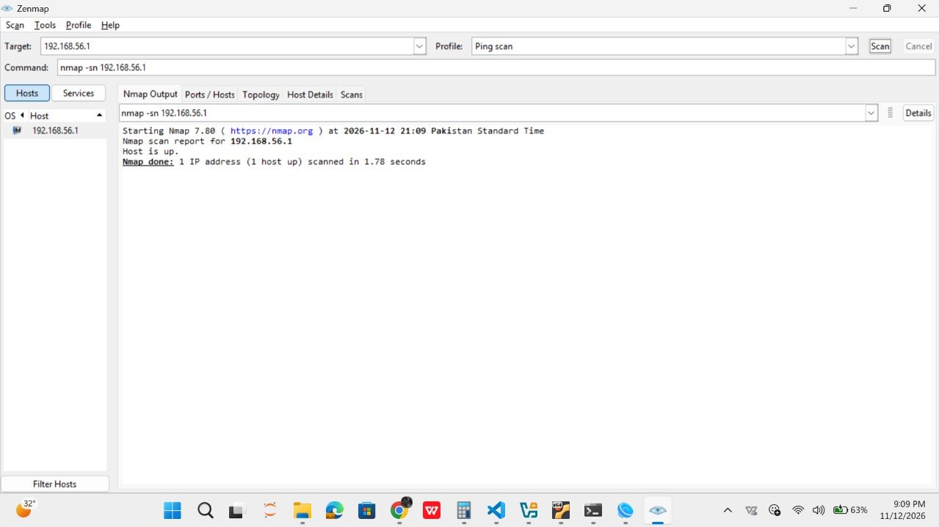
Figure 7: Zenmap ping scan of 192.168.56.1 on Windows - 1 host up.
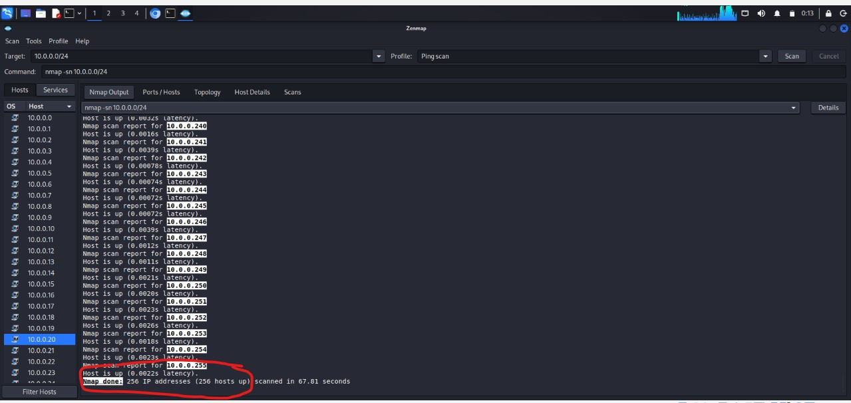
Figure 8: Zenmap ping scan of 169.254.141.170 on Windows - 1 host up.
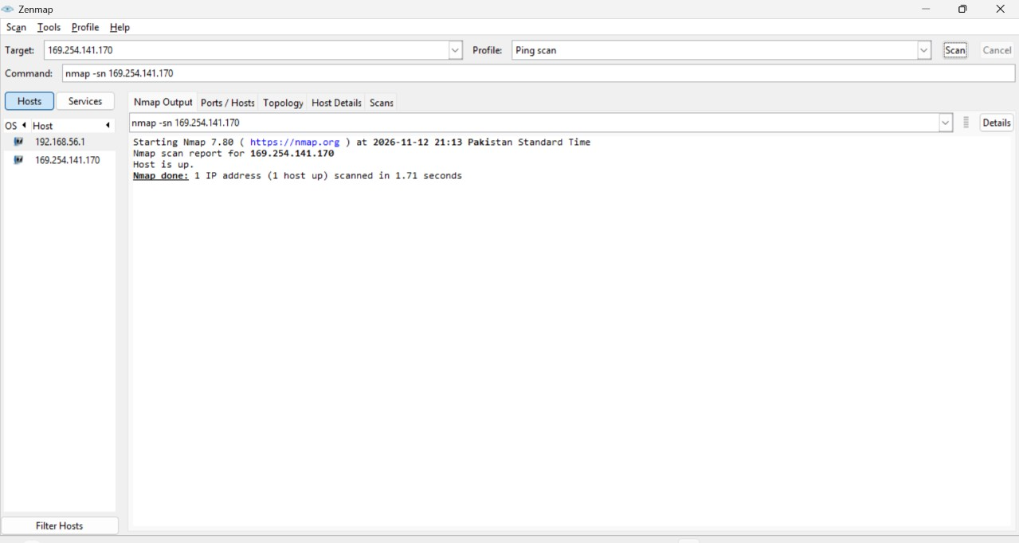
Figure 9: Zenmap on Kali starting a ping scan of 10.0.0.0/24 (nmap -sn 10.0.0.0/24).
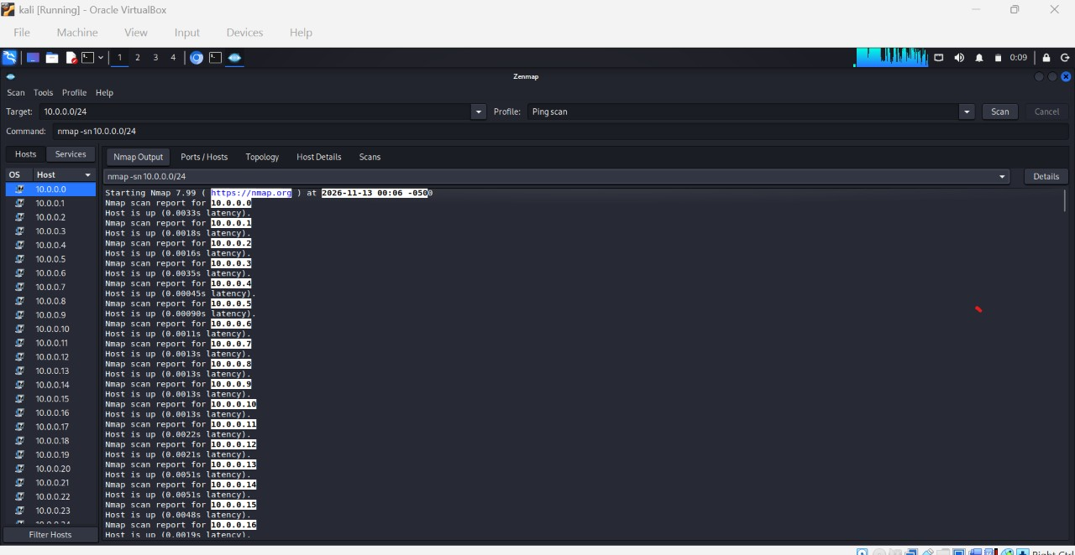
Figure 10: Scan completed - 256 IP addresses (256 hosts up) scanned in 67.81 seconds.
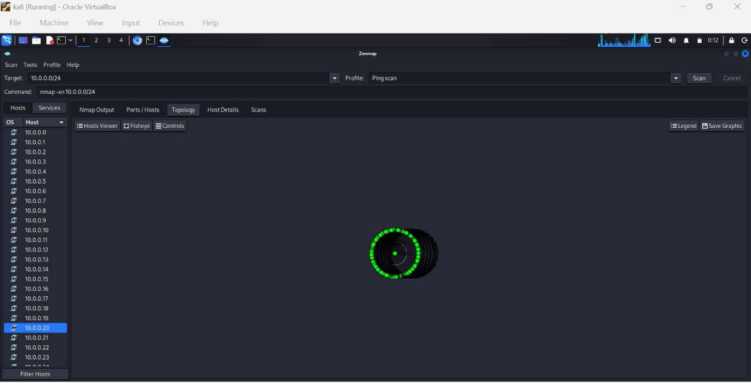
Figure 11: Zenmap Topology tab - first view of the 10.0.0.0/24 scan.
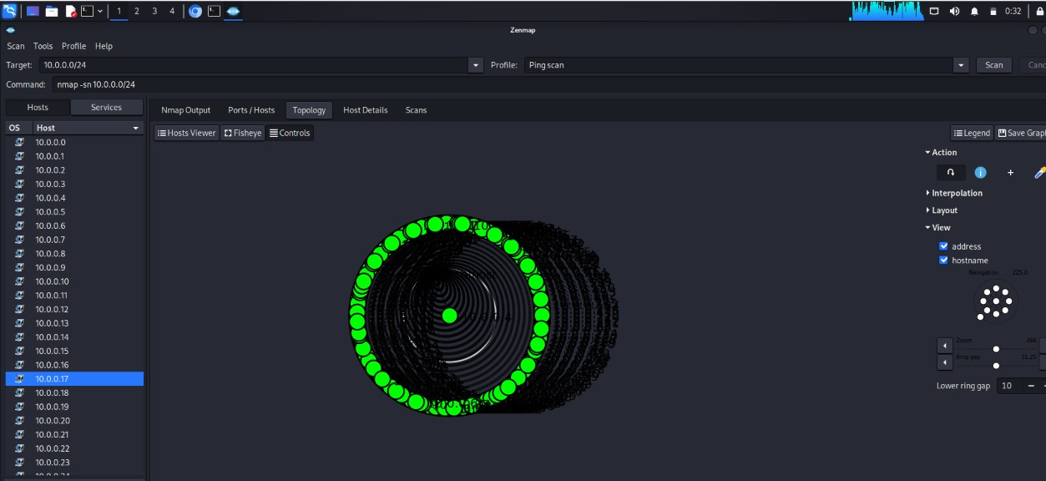
Figure 12: Zenmap Topology tab with address and hostname labels turned on.
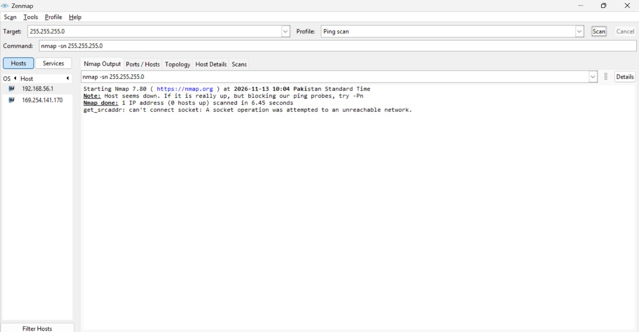
Figure 13: Mistake - scan of the subnet mask 255.255.255.0 returned 0 hosts up.
-End-
👤 Author
Muhammad Yaqoob (MYMB)
Cybersecurity Professional B082
LinkedIn: https://www.linkedin.com/in/muhammad-yaqoob-843822302
📌 Project Information
Program Name: Cybersecurity program at Networkwalks | Week: 02 | Repository: GitHub

